LOW POWER TRANSMIISION USING LORA
TECHNOLOGY

E.G.Pradeep
B.TECH.ECE
SRM Institute of Science and Technology,Tiruchirappalli, India
egpradeep2005@gmail.com

B.Prasanth
B.TECH.ECE
SRM Institute of Science and Technology,Tiruchirappalli, India
bprasanth0803004@gmail.com

Dr.M.Mathan Kumar
Assistant Professor
Electrical and Electronics Engineering SRM Institute of Science and Technology,Tiruchirappalli,India
mathankumarbit@gmail.com

Abstract—New technologies have emerged which enable power efficient communication over very long distances. Examples of such Low-Power Wide-Area Network (LPWAN) technologies.A typical application scenario for these technologies is city where devices send readings at very low frequency over a long distance to a data concentrator (one-hop networks).LoRa (Long Range) is a technique that enables the long-range transfer of information with a low transfer rate. This paper presents a review of the challenges and the obstacles of Interference concept with emphasis on the LoRa technology. Along with that the demand for low-power and long-range, large amount of data transmission arises. However, there has been no such communication technology to satisfy the transmission. The Wi-Fi is able to send large amounts of data but because of high power consumption, it has to use firm power. The LoRa technology is available for long-range and low-power communication.
KeyWords:LPWAN,LoRa,Long-range,data,Long distance,Communication.

Ⅰ. INTRODUCTION
In the era of the Internet of Things (IoT), the need for reliable, energy-efficient, and long-range wireless communication has led to the emergence of Low Power Wide Area Network (LPWAN) technologies. Among them, LoRaWAN (Long Range Wide Area Network) stands out as one of the most widely adopted standards for connecting battery-powered devices to the internet over long distances. Developed and maintained by the LoRa Alliance, LoRaWAN is designed to support secure, bidirectional communication between end devices and gateways using unlicensed radio frequency bands such as 868 MHz in Europe and 915 MHz in North America. The core technology behind LoRaWAN is LoRa (Long Range), a proprietary spread-spectrum modulation technique based on Chirp Spread Spectrum (CSS) developed by Semtech Corporation. This modulation allows LoRa to achieve robust, long-range communication — often exceeding 10 km in rural areas and 2–5 km in urban environments — while consuming very low power, making it ideal for IoT applications like smart agriculture, industrial monitoring, smart metering, and environmental sensing.
LoRaWAN defines the communication protocol and system architecture, including the roles of end devices, gateways, network servers, and application servers. End devices transmit data packets to gateways, which then forward them to a centralized network server via IP connections. The network server authenticates and manages these communications, enabling seamless data transfer to the appropriate application server. Due to its star-of-stars topology and ability to support thousands of devices, LoRaWAN provides a scalable and cost-effective solution for long-range IoT deployments. Furthermore, its support for adaptive data rates, encryption, and network optimization makes it a powerful platform for secure, low-maintenance wireless communication across vast geographic areas.
Ⅱ. LITERATURE REVIEW
LoRa-based wireless communication has emerged as a key enabler for long-range, low-power IoT applications, particularly in remote environments where traditional network infrastructure is limited. The SX1276 transceiver module operating at 915 MHz has been widely adopted in academic and industrial research due to its high sensitivity and low power requirements. Interfacing the SX1276 with STM32 microcontrollers has gained traction as a practical solution for implementing efficient wireless sensor networks. STM32, with its ARM Cortex-M core and versatile peripheral support, allows seamless SPI-based communication with the LoRa module, enabling reliable transmission of environmental, agricultural, or industrial sensor data. Studies from the past two years have demonstrated the deployment of such systems in smart farming, weather monitoring, and structural health monitoring projects. These works highlight the ability of STM32-SX1276 pairs to provide secure, long-distance communication while conserving battery power, making them suitable for deployment in inaccessible areas.
Proceedings from recent IEEE conferences report improved network stability and data integrity in LoRa-based STM32 systems when Adaptive Data Rate (ADR) and sleep modes are utilized. Experiments have shown successful communication ranges of up to 10 km in rural areas with minimal packet loss. The integration of real-time operating systems such as FreeRTOS has further enhanced task scheduling and system responsiveness. These systems are often complemented by cloud integration for centralized monitoring and analysis, improving scalability and user accessibility. As research continues, the STM32 and LoRa SX1276 combination remains a promising architecture for smart infrastructure applications. By promoting decentralized data acquisition and long-range transmission, such systems demonstrate a practical and cost-effective alternative to traditional short-range or power-intensive wireless solutions.

Ⅲ. METHODOLOGY
The proposed methodology utilizes the LoRa SX1276 transceiver module interfaced with an STM32 microcontroller to enable long-range, low-power wireless communication suitable for various IoT-based monitoring applications. The system is configured to operate at 915 MHz, offering improved signal penetration and reduced interference, especially in semi-urban and rural environments. Communication between the SX1276 and STM32 is achieved via the Serial Peripheral Interface (SPI), with HAL libraries used for low-level hardware control and efficient data transmission. Sensor modules such as DHT11 for temperature and humidity or MQ2/MQ135 for gas detection are integrated into the STM32 board, and data from these modules is periodically transmitted via LoRa.
Data packets are encoded and framed in a lightweight format to minimize payload size, ensuring reliable transmission over long distances. On the receiver end, another STM32-SX1276 pair decodes the transmitted signals and displays them on an I2C-based OLED screen or forwards them to a cloud server for analysis and logging. To enhance system responsiveness, FreeRTOS is used for concurrent task management. Adaptive Data Rate (ADR) features are enabled for dynamic adjustment of transmission parameters based on signal quality, ensuring power efficiency.
The gateway, acting as a central node, aggregates data from multiple sensor nodes and pushes it to an Application Enablement Platform (AEP) using MQTT or HTTP protocols. Collected data can then be used for analytics in sectors like environmental monitoring, smart agriculture, and structural health tracking. Unique MAC addressing of STM32 devices facilitates node identification, aiding in system diagnostics and scalability. This architecture supports real-time monitoring, zone-based deployment, and minimal maintenance. The integration of low-power wide-area network (LPWAN) technology like LoRa with robust STM32 microcontrollers enhances the reach and reliability of IoT systems, contributing significantly to smart city initiatives and remote monitoring infrastructures.

IV. PROPOSED ARCHITECTURE
The proposed architecture for interfacing the LoRa SX1276 module with the STM32 microcontroller (LR1276-915MHz) consists of two main modules: the transmitter node and the receiver node, designed for long-range, low-power wireless data communication.

A. Transmitter Node:
This node is responsible for collecting environmental data such as temperature and humidity. It comprises an STM32 microcontroller, DHT11 sensor, LoRa SX1276 module, and a power supply unit (battery or USB). The microcontroller processes sensor data and transmits it wirelessly via the LoRa module. The LoRa SX1276 operates in the 915MHz band, allowing reliable communication over long distances, even in areas with low connectivity. Data is sent at regular intervals or upon trigger conditions, like threshold breach.

B. Receiver Node:
The receiver unit also uses an STM32 microcontroller and a LoRa SX1276 module to receive the transmitted data. An OLED I2C display (0.96 inch) is connected to the STM32 to display real-time temperature and humidity readings. The system ensures low power consumption and efficient data transmission over long distances, making it ideal for remote weather stations, smart farming, or IoT monitoring applications.
The two nodes communicate via LoRa wireless protocol, ensuring long-range coverage with minimal power usage. The receiver node can be extended to include data logging or cloud integration capabilities for further processing and analytics.
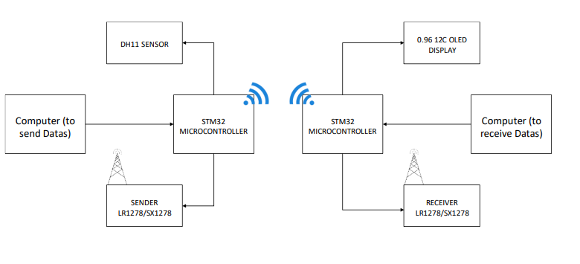
Fig.4.1.Block Diagram
V. WORKING PRINCIPLE
The proposed system utilizes long-range, low-power communication by interfacing the LoRa SX1276 (915 MHz) transceiver module with an STM32 microcontroller. The primary function of this setup is to wirelessly transmit environmental sensor data—such as temperature and humidity—from a sender (transmitter) module to a receiver module over LoRa communication.
The sender module, integrated with a DHT11 sensor and STM32 microcontroller, periodically collects temperature and humidity data. This data is processed by the STM32 and sent to the LoRa SX1276 module, which then transmits the encoded information wirelessly using the 915 MHz frequency band.
At the receiver end, another STM32 microcontroller interfaces with a LoRa SX1276 module to receive the transmitted data. Once received, the STM32 decodes the data and displays it on an OLED screen connected via I2C interface. The system ensures real-time monitoring of environmental data at a long distance without the need for internet connectivity.
This architecture allows for efficient communication between two STM32-based embedded systems in remote or IoT-based environments. The low-power characteristics of LoRa ensure long operational life when powered by battery, while STM32 ensures reliable and efficient signal processing.[Fig 5.1]

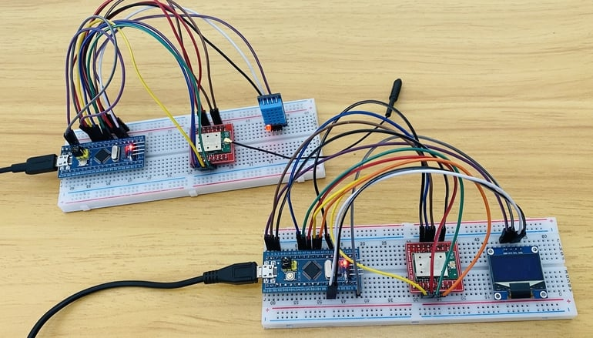
Fig 5.1.Prototype Hardware Setup

VI. MAJOR COMPONENTS
A. STM32 Microcontroller [Fig 4.1]:
The STM32 microcontroller, part of the ARM Cortex-M family, serves as the central processing unit for the LoRa communication system. It interfaces with sensors, processes incoming data, and communicates with the LoRa SX1276 module using SPI. STM32 is known for its low power consumption, real-time performance, and peripheral-rich architecture, making it suitable for embedded applications requiring precise control and efficient data handling.
B. LoRa SX1276 Module (LR1276-915MHz) [Fig 4.2]:
The LoRa SX1276 module is a long-range, low-power transceiver operating in the 915 MHz ISM band. It uses spread spectrum technology and FSK modulation to ensure robust and secure data transmission over several kilometers. It is ideal for wireless sensor networks and remote IoT applications where reliable communication is crucial even in the presence of obstacles or interference.
C. DHT11 Sensor
The DHT11 sensor is used to measure temperature and humidity. It has a digital output that can be easily interfaced with the STM32 microcontroller. The sensor plays a vital role in environmental monitoring applications by providing real-time data that is transmitted via LoRa.
D. Power Supply Module
A regulated power supply unit provides stable voltage (typically 3.3V or 5V) to all system components, including the STM32 microcontroller, DHT11 sensor, and the LoRa module. Proper power management ensures system reliability and protects components from voltage fluctuations.
E. Antenna [Fig 4.5]:
The antenna, connected to the LoRa module, is essential for transmitting and receiving RF signals. A properly tuned antenna enhances signal strength and communication range, especially in outdoor or long-distance applications.
VII. RESULTS AND EVALUATION
The implementation of the LoRa-based wireless communication system using the SX1276 module and STM32 microcontroller has been successfully tested for reliable long-range data transmission in real-time environmental monitoring scenarios. The system's performance was evaluated in terms of signal strength, data accuracy, transmission range, and energy efficiency.
Key outcomes of the evaluation include:
- Stable Long-Range Communication:
The LoRa SX1276 module, operating at 915 MHz, consistently achieved reliable communication over distances exceeding 2 kilometers in open environments, making it suitable for remote sensing and telemetry applications.
- Accurate Sensor Data Transmission:
Data collected from the DHT11 sensor (temperature and humidity) was transmitted accurately and in real time between the sender and receiver nodes without significant packet loss or corruption.
- Low Power Consumption:
The STM32 microcontroller and SX1276 module demonstrated low power operation, validating the system’s suitability for battery-powered or solar-powered remote deployments.
- Robust Performance in Interference-Prone Areas:
Field tests confirmed that the LoRa system maintained consistent performance in moderately obstructed urban environments, highlighting its resilience compared to other short-range wireless technologies.
- System Integration and Flexibility:
The modular design allowed easy integration with additional sensors or processing logic. The use of SPI communication between STM32 and SX1276 ensured fast and efficient data handling.
These results validate the system’s effectiveness for low-power, long-range IoT applications such as environmental monitoring, smart agriculture, or remote alert systems. The successful integration and performance testing highlight the potential scalability of the architecture for broader IoT use cases.
Ⅷ.FUTURE WORKS
In future iterations, the system integrating the LoRa SX1276 with the STM32 microcontroller can be significantly enhanced to improve wireless communication efficiency, reduce power consumption, and enable broader real-time monitoring capabilities in smart environments. One possible advancement includes the implementation of adaptive transmission control, where transmission intervals and data rates are dynamically adjusted based on environmental factors or system priorities to further optimize energy efficiency.
Additionally, edge computing functionalities could be embedded into the STM32 microcontroller to locally process sensor data, thereby reducing the need for frequent data transmission and conserving network bandwidth. Encryption techniques and secure key exchange protocols can be incorporated to ensure secure communication in sensitive applications such as remote health monitoring or industrial control systems.
The integration of energy harvesting modules (e.g., solar or piezoelectric) can enable the deployment of completely autonomous, battery-less LoRa nodes in remote or hard-to-reach areas. Furthermore, combining the LoRa system with other wireless protocols (such as BLE or Zigbee) can create hybrid networks that adapt to varying data rate and range requirements.
Advanced use cases could include remote environmental surveillance, smart agricultural automation, disaster early-warning systems, and interconnected sensor grids for smart cities. With AI-driven analytics, the collected data from distributed LoRa nodes can be used to generate predictive insights and improve decision-making in critical infrastructures.
These enhancements aim to elevate the practicality and scalability of LoRa-STM32 based systems in diverse domains, enabling cost-effective, low-power, and long-range IoT solutions for the future.
Ⅸ.CONCLUTION
In conclusion, the interfacing of the LoRa SX1276 module operating at 915 MHz with the STM32 microcontroller offers an effective low-power, long-range wireless communication platform well-suited for modern IoT applications. This system successfully demonstrates real-time data transmission with minimal energy consumption, leveraging the STM32’s efficient processing capabilities and the LoRa module’s robust long-distance communication features.
The deployment enables reliable wireless connectivity for scenarios where conventional communication protocols (like Wi-Fi or Bluetooth) fall short, particularly in remote environments and sensor networks. The compact design, low power usage, and scalability of this configuration make it highly applicable for smart agriculture, environmental monitoring, and smart city infrastructure.
The use of SPI interface for seamless communication between the STM32 and the SX1276, along with the implementation of power-saving modes and periodic data transfer routines, illustrates the viability of deploying energy-efficient IoT nodes for long-term monitoring.
Future improvements may focus on increasing system intelligence through edge computing capabilities, enhancing network security, and optimizing transmission strategies for even lower energy consumption. The outcomes of this study demonstrate the promising potential of LoRa-STM32 based solutions in addressing the connectivity needs of large-scale, power-constrained IoT deployments.

Ⅸ.References
1.D. H. Kim, J. Y. Lim and J. D. Kim,“Low-Power, Long-Range, High-Data Transmission Using Wi-Fi and LoRa”, 6th International Conference on IT Convergence and Security (ICITCS), Prague, Czech Republic, 2016, pp. 1-3,
DOI: 10.1109/ICITCS.2016.7740351.

2. U. Noreen, A. Bounceur and L. Clavier, “A study of LoRa low power and wide area network technology”, International Conference on Advanced Technologies for Signal and Image Processing (ATSIP), Fez, Morocco,pp. 1-6, DOI: 10.1109/ATSIP.2017.8075570.

3.Sanchez-Iborra, R., G. Liaño, I., Simoes, C., Couñago, E.,& Skarmeta, A. F. . ,“Tracking and monitoring system basedon LoRa technology for lightweight boats”.December 2018.Electronics 8(1):15DOI: 10.3390/electronics8010015LicenseCC BY 4.0

4.Ziqi Lin, Xu Zhang, Shimin Gong, Lanhua Li, Zhou Su, Bo Gu,“Matching-Driven Deep Reinforcement Learning for Energy-Efficient Transmission Parameter Allocation in Multi-Gateway LoRa Networks”.From: Xu Zhang [view email]
[v1] Sat, 16 Sep 2023 11:37:23 UTC (2,953 KB)

5.Ziqi Lin, Xu Zhang, Shimin Gong, Lanhua Li, Zhou Su, Bo Gu,“Matching-Driven Deep Reinforcement Learning for Energy-Efficient Transmission Parameter Allocation in Multi-Gateway LoRa Networks”.From: Ziqi Lin [view email]
[v1] Thu, 18 Jul 2024 00:54:26 UTC (2,126 KB)

6.Ganghui Lin, Ahmed Elzanaty, Mohamed-Slim Alouini,“LoRa Backscatter Communications: Temporal, Spectral, and Error Performance Analysis”.From: Ganghui Lin [view email] [v1] Sun, 4 Jun 2023 10:30:04 UTC (8,299 KB)
[v2] Tue, 20 Jun 2023 14:33:44 UTC (8,323 KB)

7.Ryotai Airiyoshi, Mikio Hasegawa, Tomoaki Ohtsuki, Aohan Li,“Energy Efficient Transmission Parameters Selection Method Using Reinforcement Learning in Distributed LoRa Networks)”.From: Aohan Li [view email]
[v1] Tue, 15 Oct 2024 04:49:56 UTC (2,355 KB)
[v2] Wed, 22 Jan 2025 04:25:10 UTC (2,354 KB)

8.Jesse Duran;Yiyan Li,“An Ultra Low Power LoRa Mesh for Low Cost and Real Time Resort Pool Temperature Monitoring”.DOI:10.1109/ICETCI57876.2023.10177034

9.Eynar Calle Viles; Edgar Roberto Ramos Silvestre; Elias Brayan Choque Maydana; Wilder Orellana Lopez; Cristian Capriles Olivera,“Performance Assessment of a Low Power Wide Area wireless Networks based on Lora Technology using IOT devices in different Bolivia Areas ”.DOI:10.1109/ETCM63562.2024.10746217

10.Diyuan Shen;Ling Huang;Xiaobo Zhang;Zhangqin Huang,“Research on ReaL Time Data Wireless Communication System Based on LoRa Technology”.DOI:10.1109/ICCCS61882.2024.10602933

